Year 10
OLNA class

Test 3

2018

Number- Rounding and BIDMAS


Name: ______________________ Class: ______ Time: 25 minutes (strict) Total Mark:____/19

Resources: No calculator allowed

Question 1 3 marks

Consider the number 39 461 and perform the following:
a) | Round to the nearest thousand
b) | Round to the nearest hundred
c) | Round to the nearest ten

Question 2 2 marks

Marilyn and Kim disagree about the answer to the following calculation:
8.6 + 9.2 + 8.7 + 8.8 + 8.9 + 9.3 + 9.4 + 8.6.
Marilyn says the answer is 81.5, but Kim thinks it is 71.5. Obtain and write an estimate for the calculation and determine who is correct.

Question 3 10 marks [1, 2, 7]

Julian is selling tickets for his school’s theatre production of South Pacific. So far he has sold 439 tickets for Thursday night’s performance, 529 for Friday’s and 587 for Saturday’s. The costs of the tickets are $9.80 for adults and $4.90 for students.
a) | Round the figures to the nearest hundred to estimate the number of tickets Julian has sold so far.
b) | If approximately half the tickets sold were adult tickets and the other half were student tickets, estimate how much money has been received so far by rounding the cost of the tickets to the first digit.
c) | By rounding the item price to the first digit, use the following table to estimate how much each item will cost Jia for the quantity she requires.  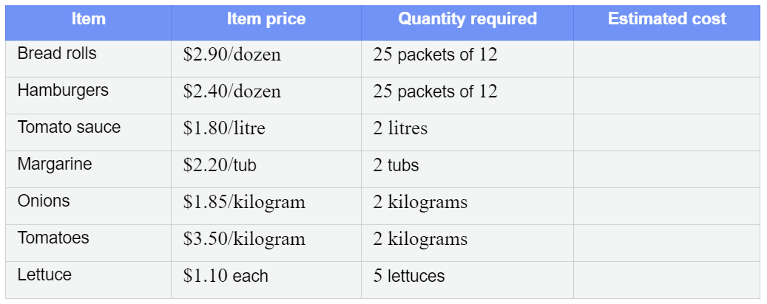
 | Extra space for working out:

Question 4 2 marks

Calculate
a) | 12 ÷ 2 + 4 × (4 + 6) | b) | 80 ÷ {[(11 − 2) × 2] + 2}.

Question 5 2 marks

James and Liz discovered that they had different answers to the same question, which was to calculate 6 + 6 ÷ 3. James thought the answer was 8. Liz thought the answer was 4. Who was correct, James or Liz? Provide an explanation.

END OF TEST

